1040105新聞附件
Decisions adopted by COP 20 and CMP 10
COP 20
- Lima Call for Climate Action (686 kB)
- Warsaw International Mechanism for Loss and Damage associated with climate change impacts (24 kB)
- National adaptation plans (21 kB)
- Report of the Adaptation Committee (102 kB)
- Long-term climate finance (90 kB)
- Report of the Standing Committee on Finance (97 kB)
- Report of the Green Climate Fund to the Conference of the Parties and guidance to the Green Climate Fund (102 kB)
- Report of the Global Environment Facility to the Conference of the Parties and guidance to the Global Environment Facility (25 kB)
- Fifth review of the Financial Mechanism (177 kB)
- Further guidance to the Least Developed Countries Fund (21 kB)
- Methodologies for the reporting of financial information by Parties included in Annex I to the Convention (86 kB)
- Fifth Assessment Report of the Intergovernmental Panel on Climate Change (13 kB)
- Guidelines for the technical review of information reported under the Convention related to greenhouse gas inventories, biennial reports and national communications by Parties included in Annex I to the Convention (248 kB)
- Training programme for review experts for the technical review of greenhouse inventories from Parties included in Annex I to the Convention (100 kB)
- Training programme for review experts for the technical review of biennial reports and national communications from Parties included in Annex I to the Convention (97 kB)
- Joint annual report of the Technology Executive Committee and the Climate Technology Centre and Network for 2013 (85 kB)
- Joint annual report of the Technology Executive Committee and the Climate Technology Centre and Network for 2014 (94 kB)
- Forum and work programme on the impact of the implementation of response measures (97 kB)
- Parties included in Annex I to the Convention whose special circumstances are recognized by the Conference of the Parties (12 kB)
- Lima work programme on gender (167 kB)
- The Lima Ministerial Declaration on Education and Awareness-raising (92 kB)
- Administrative, financial and institutional matters (147 kB)
- Revisions to the financial procedures for the Conference of the Parties, its subsidiary bodies and the secretariat (17 kB)
- Dates and venues of future sessions

CMP 10
- Report of the Adaptation Fund Board （132 kB）
- Second review of the Adaptation Fund （90 kB）
- Date of completion of the expert review process under Article 8 of the Kyoto Protocol for the first commitment period （22 kB）
- Guidance relating to the clean development mechanism （123 kB）
- Guidance on the implementation of Article 6 of the Kyoto Protocol （89 kB）
- Synergy relating to accreditation under the mechanism of the Kyoto Protocol （86 kB）
- Outcome of the work programme on modalities and procedures for possible additional land use， land-use change and forestry activities under the clean development mechanism （82 kB）
- Administrative， financial and institutional matters （146 kB）

Resolution adopted by COP 20 and CMP 10
- Expression of gratitude to the Government of the Republic of Peru and the people of the city of Lima (17 kB)
Source: 秘魯利馬氣候會議決議文公布網址http://unfccc.int/2860.php
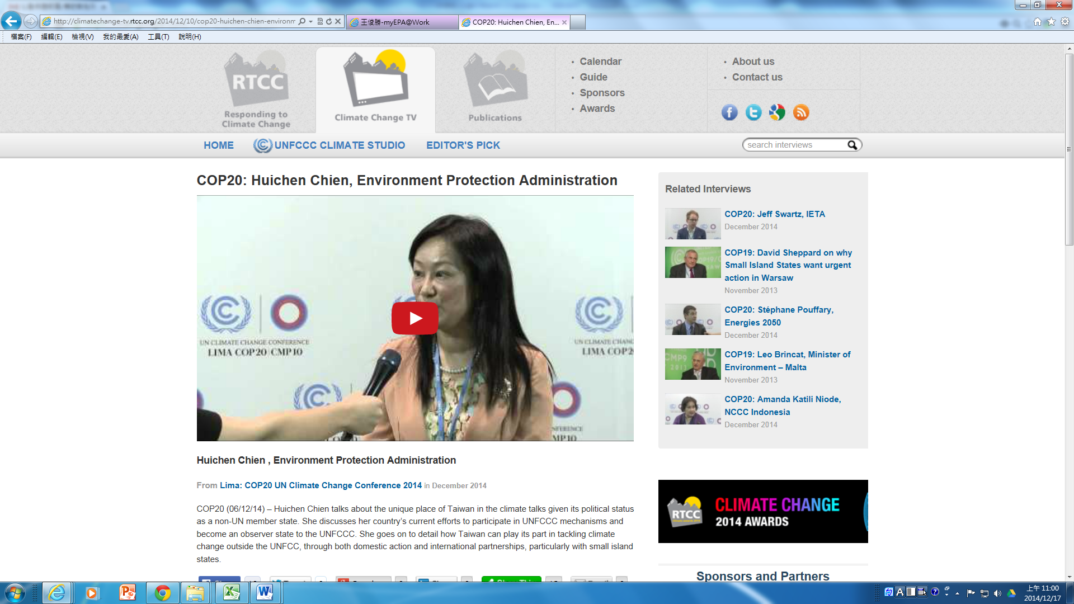
我團簡執行秘書接受UNFCCC CLIMATE STUDIO專訪
http://climatechange-tv.rtcc.org/2014/12/10/cop20-huichen-chien-environment-protection-administration/
我團舉辦周邊會議獲載於IISD COP20每日新聞報導
http://www.iisd.ca/climate/cop20/enbots/6dec.html

